# Data Vizualization: Which Chart to use? When? and Why?

Intuitively most of us know which data vizualization chart is fit for what purpose, but I think some of us make our charts less intuitive for our users, as we use the more complicated representations, or worse, 3D charts. In this article I will try and give the reasons based on years of research, of which Data Vizualization we should use for which problem statement.

As a first step, we will need to understand some principles of how the human brain perceives visual information. Famous artists have always understood how to fool the human eye and used the principles in their works of art. See below painting as an example

By Pere Borrell del Caso - Collection Banco de España, Madrid, Public Domain, https://commons.wikimedia.org/w/index.php?curid=12968243

Lets walk through some of these principles. I will only touch on the ones that are relevant to charting

## Occlusion

Occlusion is a synonym for obstructing. On a plain, when we when one object occludes (hides/covers) another object, the human brain perceives that the thing being hidden is behind, and hence farther away from the object that is in front.

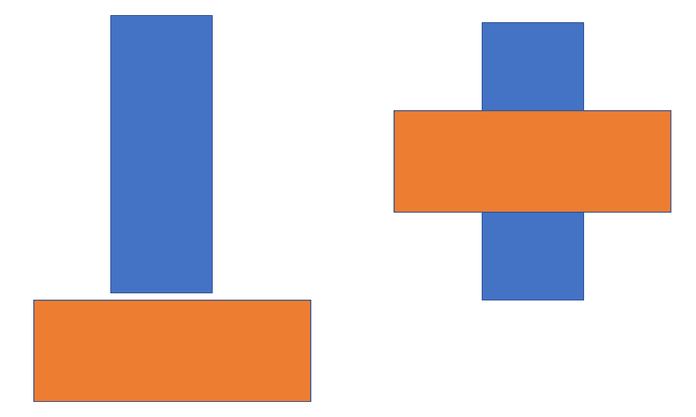

Occlusion example

In the above image we see two Identical set of objects on left and right. On the right, the object in front occludes the object behind, hence our brain perceives the occluded object being farther away.

Occlusion is the strongest cue to the human brain when it comes to visualization.

Let us now move on to the 2nd concept.

## Foreshortning OR Perspective Distortion

When we view objects in 3D, the objects farther away appear smaller, but our brain perceives them to be of the larger size than in the picture and it uses past visual experiences to make that adjustments. See an example below.

PantheraLeo1359531, CC BY 4.0 <https://creativecommons.org/licenses/by/4.0>, via Wikimedia Commons